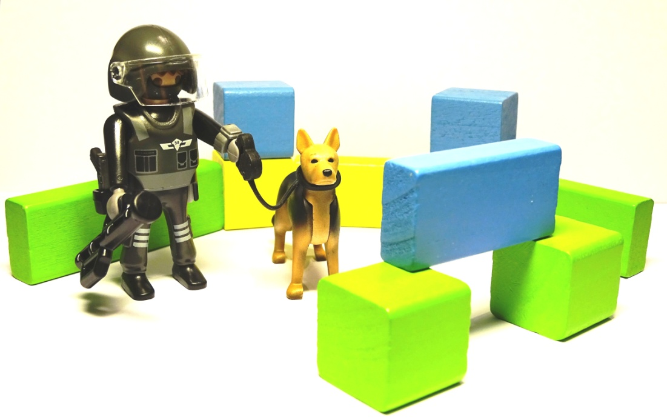
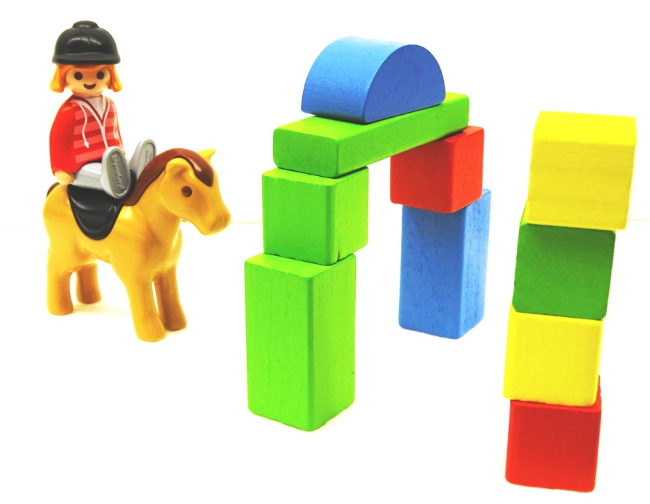
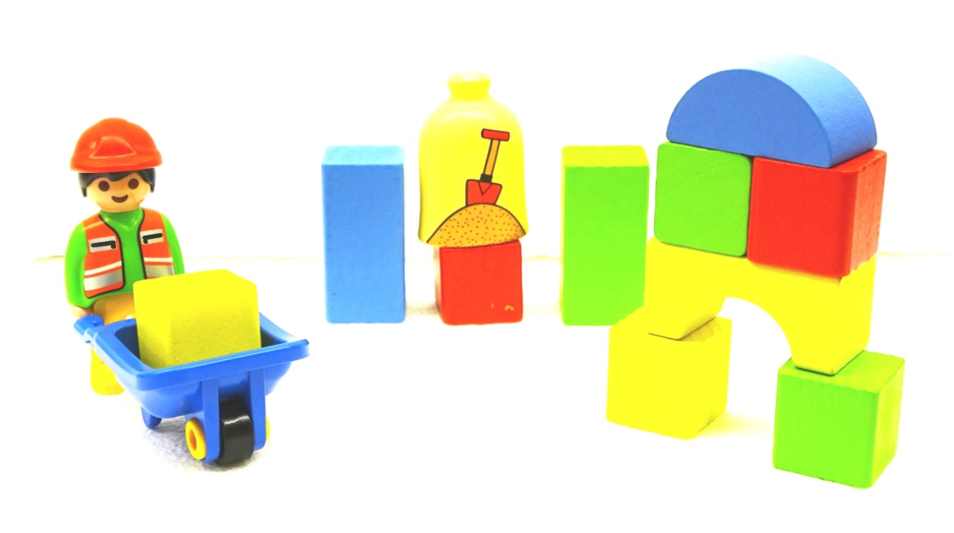
Explain the task with spoken words:

„Arrange a scene with Playmobil-figures.
Don´t speak; just facial expression and gestures are allowed.
All stones are to be used.
All parts, except elements for fixing (e.g. vacuum pads) are to be used.
The Playmobil-figures are ready prepared.
Look at my gestures and signs and facial expression!
I will not speak any more from now on.“
Don´t speak to the acting persons!
Use just gesture and facial expression for instruction!
The goal is reached, when the main features are perceptible,
like position and relation of the parts to each other.
Latest after 5 minutes the experiment is to be stopped.
The acting persons get this solution sheet and judge themselves.
Explain the task with spoken words:

„Arrange a scene with Playmobil-figures.
Don´t speak; just facial expression and gestures are allowed.
All stones are to be used.
All parts, except elements for fixing (e.g. vacuum pads) are to be used.
The Playmobil-figures are ready prepared.
Look at my gestures and signs and facial expression!
I will not speak any more from now on.“
Don´t speak to the acting persons!
Use just gesture and facial expression for instruction!
The goal is reached, when the main features are perceptible,
like position and relation of the parts to each other.
Latest after 5 minutes the experiment is to be stopped.
The acting persons get this solution sheet and judge themselves.
Explain the task with spoken words:

„Arrange a scene with Playmobil-figures.
Don´t speak; just facial expression and gestures are allowed.
All stones are to be used.
All parts, except elements for fixing (e.g. vacuum pads) are to be used.
The Playmobil-figures are ready prepared.
Look at my gestures and signs and facial expression!
I will not speak any more from now on.“
Don´t speak to the acting persons!
Use just gesture and facial expression for instruction!
The goal is reached, when the main features are perceptible,
like position and relation of the parts to each other.
Latest after 5 minutes the experiment is to be stopped.
The acting persons get this solution sheet and judge themselves.
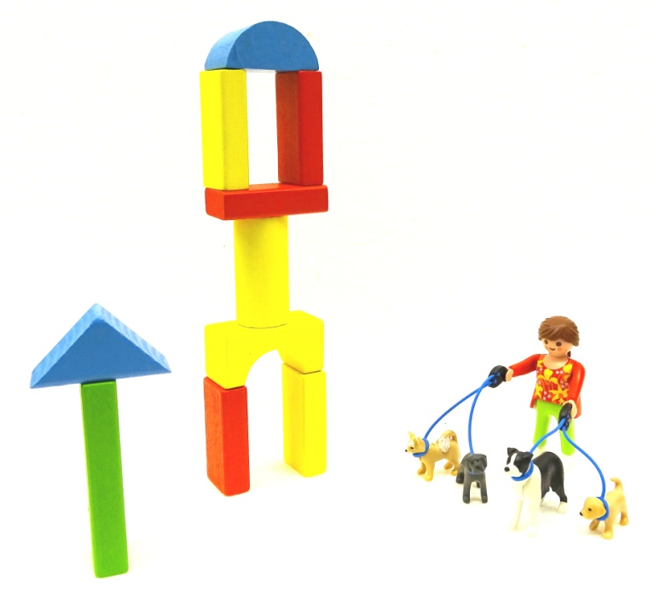
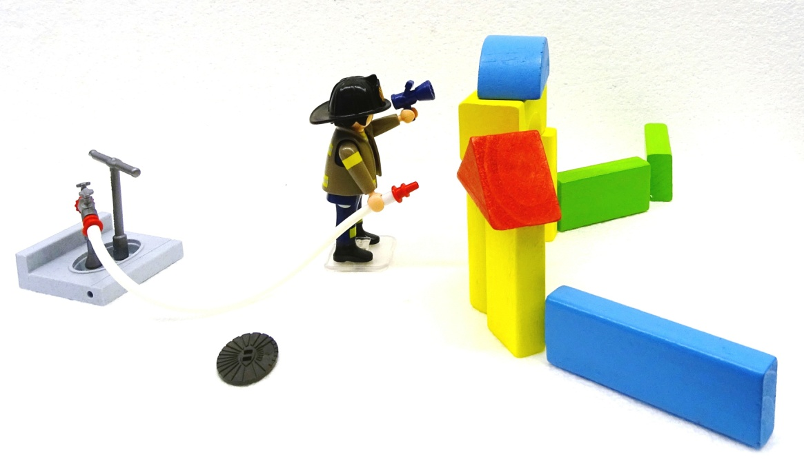
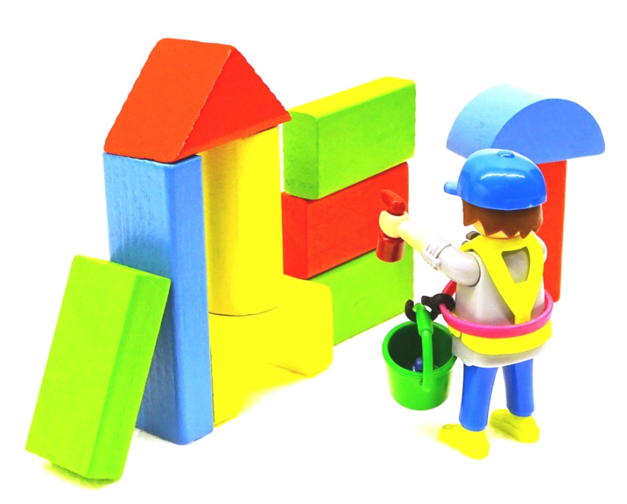
Explain the task with spoken words:

„Arrange a scene with Playmobil-figures.
Don´t speak; just facial expression and gestures are allowed.
All stones are to be used.
All parts, except elements for fixing (e.g. vacuum pads) are to be used.
The Playmobil-figures are ready prepared.
Look at my gestures and signs and facial expression!
I will not speak any more from now on.“
Don´t speak to the acting persons!
Use just gesture and facial expression for instruction!
The goal is reached, when the main features are perceptible,
like position and relation of the parts to each other.
Latest after 5 minutes the experiment is to be stopped.
The acting persons get this solution sheet and judge themselves.
Explain the task with spoken words:

„Arrange a scene with Playmobil-figures.
Don´t speak; just facial expression and gestures are allowed.
All stones are to be used.
All parts, except elements for fixing (e.g. vacuum pads) are to be used.
The Playmobil-figures are ready prepared.
Look at my gestures and signs and facial expression!
I will not speak any more from now on.“
Don´t speak to the acting persons!
Use just gesture and facial expression for instruction!
The goal is reached, when the main features are perceptible,
like position and relation of the parts to each other.
Latest after 5 minutes the experiment is to be stopped.
The acting persons get this solution sheet and judge themselves.
Explain the task with spoken words:

„Arrange a scene with Playmobil-figures.
Don´t speak; just facial expression and gestures are allowed.
All stones are to be used.
All parts, except elements for fixing (e.g. vacuum pads) are to be used.
The Playmobil-figures are ready prepared.
Look at my gestures and signs and facial expression!
I will not speak any more from now on.“
Don´t speak to the acting persons!
Use just gesture and facial expression for instruction!
The goal is reached, when the main features are perceptible,
like position and relation of the parts to each other.
Latest after 5 minutes the experiment is to be stopped.
The acting persons get this solution sheet and judge themselves.
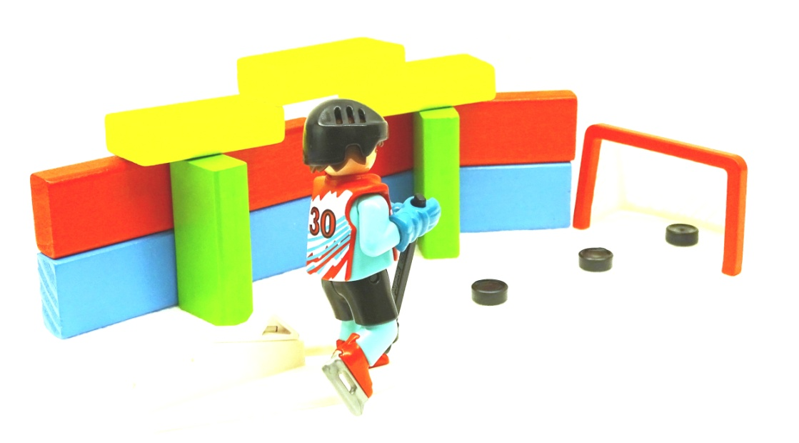
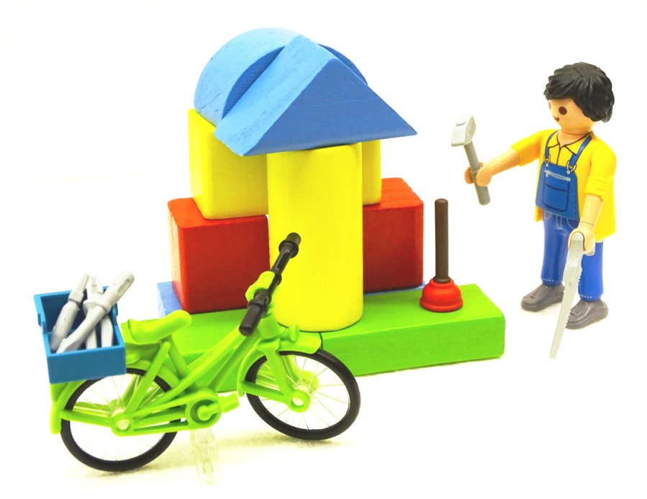
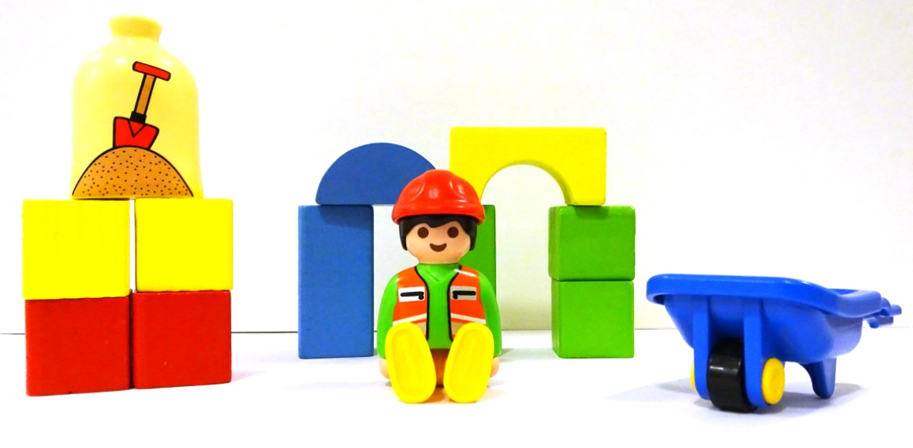
Explain the task with spoken words:

„Arrange a scene with Playmobil-figures.
Don´t speak; just facial expression and gestures are allowed.
All stones are to be used.
All parts, except elements for fixing (e.g. vacuum pads) are to be used.
The Playmobil-figures are ready prepared.
Look at my gestures and signs and facial expression!
I will not speak any more from now on.“
Don´t speak to the acting persons!
Use just gesture and facial expression for instruction!
The goal is reached, when the main features are perceptible,
like position and relation of the parts to each other.
Latest after 5 minutes the experiment is to be stopped.
The acting persons get this solution sheet and judge themselves.
Explain the task with spoken words:

„Arrange a scene with Playmobil-figures.
Don´t speak; just facial expression and gestures are allowed.
All stones are to be used.
All parts, except elements for fixing (e.g. vacuum pads) are to be used.
The Playmobil-figures are ready prepared.
Look at my gestures and signs and facial expression!
I will not speak any more from now on.“
Don´t speak to the acting persons!
Use just gesture and facial expression for instruction!
The goal is reached, when the main features are perceptible,
like position and relation of the parts to each other.
Latest after 5 minutes the experiment is to be stopped.
The acting persons get this solution sheet and judge themselves.
Explain the task with spoken words:

„Arrange a scene with Playmobil-figures.
Don´t speak; just facial expression and gestures are allowed.
All stones are to be used.
All parts, except elements for fixing (e.g. vacuum pads) are to be used.
The Playmobil-figures are ready prepared.
Look at my gestures and signs and facial expression!
I will not speak any more from now on.“
Don´t speak to the acting persons!
Use just gesture and facial expression for instruction!
The goal is reached, when the main features are perceptible,
like position and relation of the parts to each other.
Latest after 5 minutes the experiment is to be stopped.
The acting persons get this solution sheet and judge themselves.
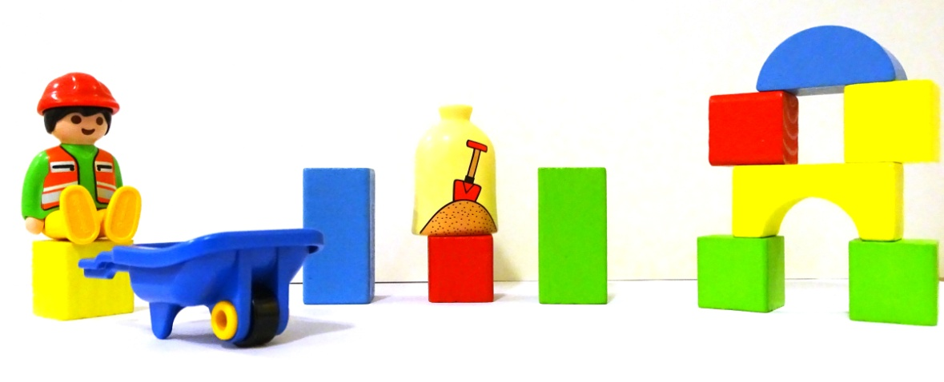
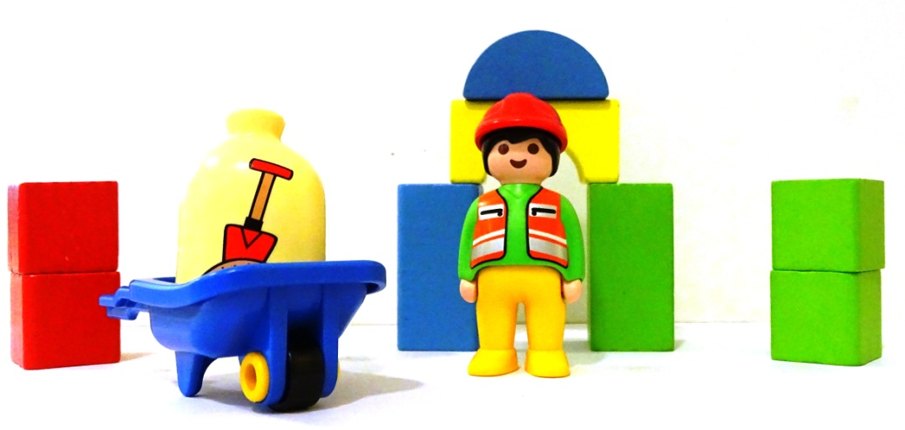
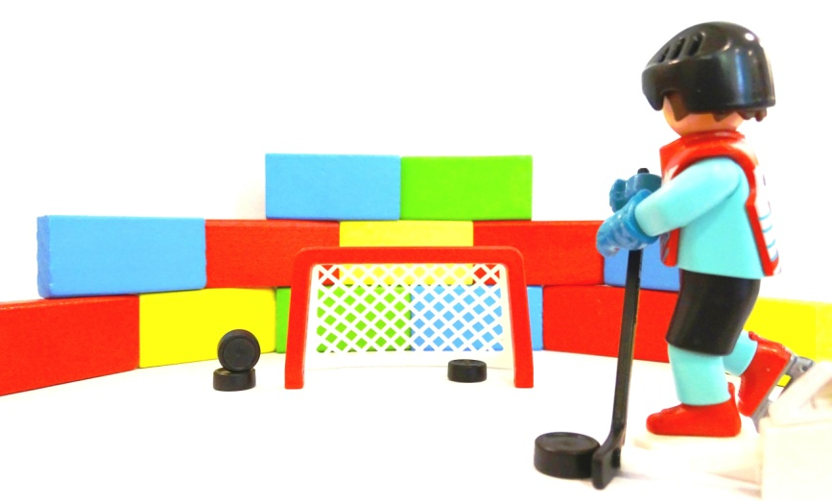
Explain the task with spoken words:

„Arrange a scene with Playmobil-figures.
Don´t speak; just facial expression and gestures are allowed.
All stones are to be used.
All parts, except elements for fixing (e.g. vacuum pads) are to be used.
The Playmobil-figures are ready prepared.
Look at my gestures and signs and facial expression!
I will not speak any more from now on.“
Don´t speak to the acting persons!
Use just gesture and facial expression for instruction!
The goal is reached, when the main features are perceptible,
like position and relation of the parts to each other.
Latest after 5 minutes the experiment is to be stopped.
The acting persons get this solution sheet and judge themselves.
Explain the task with spoken words:

„Arrange a scene with Playmobil-figures.
Don´t speak; just facial expression and gestures are allowed.
All stones are to be used.
All parts, except elements for fixing (e.g. vacuum pads) are to be used.
The Playmobil-figures are ready prepared.
Look at my gestures and signs and facial expression!
I will not speak any more from now on.“
Don´t speak to the acting persons!
Use just gesture and facial expression for instruction!
The goal is reached, when the main features are perceptible,
like position and relation of the parts to each other.
Latest after 5 minutes the experiment is to be stopped.
The acting persons get this solution sheet and judge themselves.
Explain the task with spoken words:

„Arrange a scene with Playmobil-figures.
Don´t speak; just facial expression and gestures are allowed.
All stones are to be used.
All parts, except elements for fixing (e.g. vacuum pads) are to be used.
The Playmobil-figures are ready prepared.
Look at my gestures and signs and facial expression!
I will not speak any more from now on.“
Don´t speak to the acting persons!
Use just gesture and facial expression for instruction!
The goal is reached, when the main features are perceptible,
like position and relation of the parts to each other.
Latest after 5 minutes the experiment is to be stopped.
The acting persons get this solution sheet and judge themselves.

